**Supplementary Material**

**What can we learn from multimorbidity? A deep dive from its risk patterns to the corresponding patient profiles**

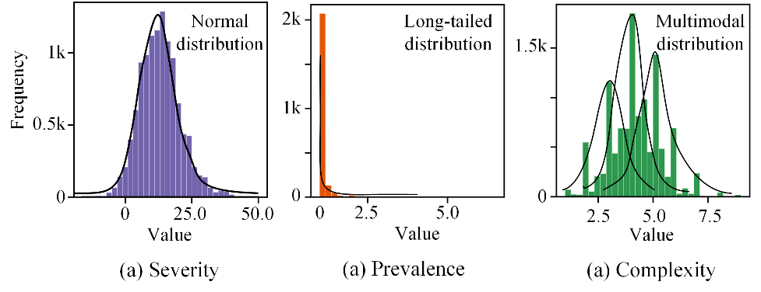

**Supplementary Fig. 1.** The distributions of three submatrices.

The MRN edge distribution is labeled by the action priority method, and the distributions of the three submatrices are first evaluated. We commence by ascertaining the bins of the three subsidiary matrices: adopting equidistant binning for normally distributed data, employing equifrequent binning to address multimodal distributed data, and utilizing quantile-based binning to aptly handle long-tailed distributions. As shown in Supplementary Fig. 1(a), the distribution of severity matrix shows a single, prominent peak with values tapering off on either side, suggesting a normal distribution (equidistant binning). The Supplementary Fig. 1(b) displays a prevalence distribution where a majority of the values are concentrated on one side of the graph, with very few values extending towards the other end. This is indicative of a distribution with a single, extreme value, which could be considered as a long-tailed distribution (quantile-based binning). The distribution of complexity matrix in Supplementary Fig. 1(c) shows three peaks of varying heights. This is an example of a multimodal distribution (equifrequency binning).

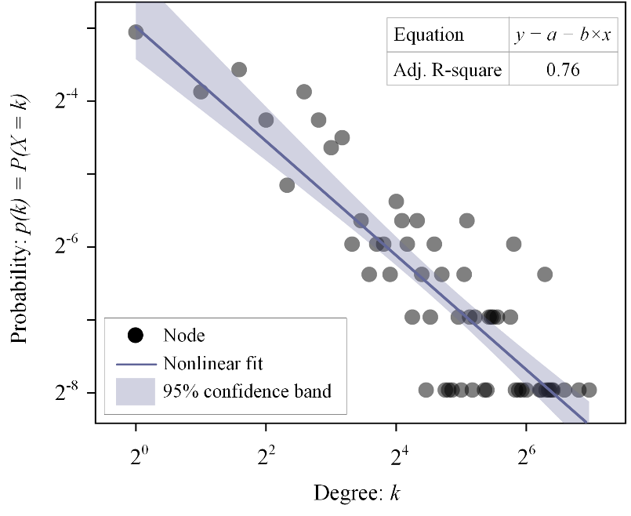

**Supplementary Fig. 2.** The degree distribution of the MRN.

Supplementary Fig. 2. depicts the degree distribution of the MRN on a log-log scale. The distribution of node degrees follows a declining trend. The nodes, represented by dots, are not uniformly distributed; instead, there are fewer nodes with a high number of connections and many nodes with fewer connections. This pattern is characteristic of scale-free networks, where the probability  of a node having  connections follow a power law, typically expressed as . The nonlinear fit line, indicated by the solid line with a shaded 95% confidence band, suggests that as the degree  increases, the probability of having that degree decreases. This is consistent with a power-law distribution. The adjusted R-square value of 0.76 indicates a moderate degree of fit to the power-law model.

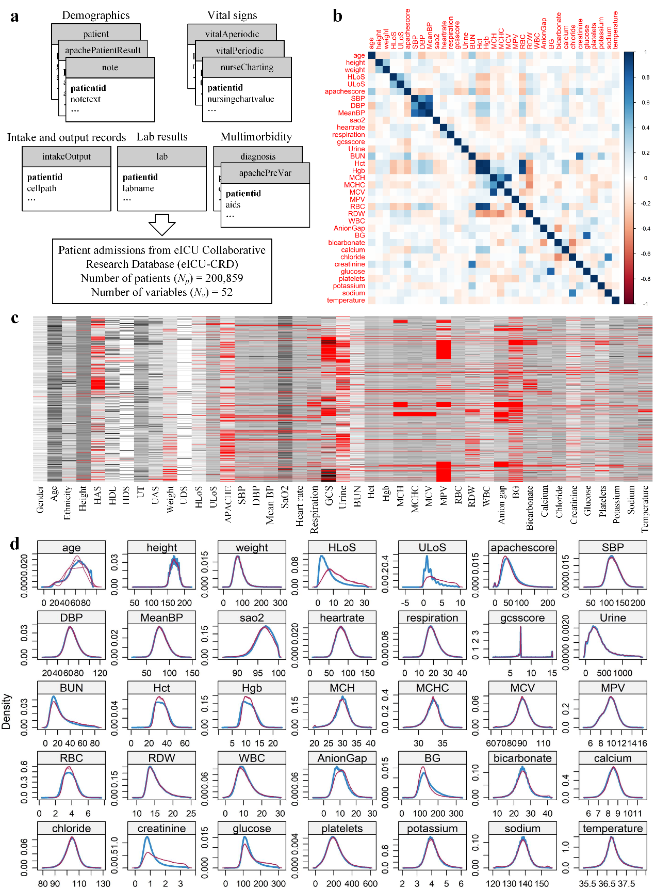

**Supplementary Fig. 3.** Experimental results of data preprocessing for machine learning.

Data extraction and integration processes are illustrated in Supplementary Fig. 3(a), with outcomes presented in tabular form (Supplementary Table 2). Eight variables are found to have more than 80% missing values. A selection process pared this set down to 44 variables, of which 35 numerical variables exhibit interrelations as depicted in the correlation matrix of Supplementary Fig. 3(b), evidencing generally tenuous correlations. Subsequent to the excision of outliers, the distribution of missing values across all variables is delineated in Supplementary Fig. 3(c). The differential density plots, pre- and post-imputation, are showcased in Supplementary Fig. 3(d), affirming that the imputation preserves the integrity of the data distribution with minimal perturbation.

Binned intervals based on clinical significance for each continuous variable are presented below:

1. Age: 0-18 years (Children and Adolescents); 19-40 years (Young Adults); 41-60 years (Middle-aged); 61-80 years (Senior); 81-90 years (Elderly).
2. BMI (Body Mass Index): <18.5 (Underweight); 18.5-24.9 (Normal Weight); 25-29.9 (Overweight); 30-34.9 (Obesity Class I); 35-39.9 (Obesity Class II); ≥40 (Severe Obesity).
3. HLoS (Hospital Length of Stay): 0-3 days (Short Stay); 4-10 days (Medium Stay); ≥11 days (Long Stay).
4. ULoS (Unit Length of Stay): 0-1 day (Short Stay); 2-3 days (Medium Stay); ≥4 days (Long Stay).
5. Apache Score: -1-39 (Mild); 40-69 (Moderate); ≥70 (Severe).
6. SBP (Systolic Blood Pressure): ≤90 mmHg (Low); 91-120 mmHg (Normal); 121-140 mmHg (Prehypertension); ≥141 mmHg (Hypertension).
7. DBP (Diastolic Blood Pressure): ≤60 mmHg (Low); 61-80 mmHg (Normal); 81-90 mmHg (Prehypertension); ≥91 mmHg (Hypertension).
8. MeanBP (Mean Blood Pressure): ≤65 mmHg (Low); 66-85 mmHg (Normal); 86-100 mmHg (Prehypertension); ≥101 mmHg (Hypertension).
9. SAO2 (Arterial Oxygen Saturation): 87-95% (Mild Hypoxemia); 96-100% (Normal).
10. HR (Heart Rate): 27-60 beats/min (Bradycardia); 61-100 beats/min (Normal); 101-156 beats/min (Tachycardia).
11. RR (Respiration Rate): 0-12 breaths/min (Bradypnea); 13-20 breaths/min (Normal); 21-38 breaths/min (Tachypnea).
12. GCS (Glasgow Coma Scale): 1-7 (Severe Coma); 8-13 (Moderate Coma); 14-15 (Alert).
13. UR (Urine Output): 0-500 ml/hr (Low Output); 501-1477 ml/hr (Normal).
14. BUN (Blood Urea Nitrogen): 1-20 mg/dL (Normal); 21-83 mg/dL (Elevated).
15. Hct (Hematocrit): 7-37% (Low); 38-50% (Normal); >50% (High).
16. Hgb (Hemoglobin): 2-11 g/dL (Low); 12-16 g/dL (Normal, Male)/12-15 g/dL (Normal, Female); >16 g/dL (High, Male)/>15 g/dL (High, Female).
17. MCH (Mean Corpuscular Hemoglobin): 20-27 pg (Low); 28-32 pg (Normal); >32 pg (High).
18. MCHC (MCH Concentration): 27-32 g/dL (Low); 33-36 g/dL (Normal); >36 g/dL (High).
19. MCV (Mean Corpuscular Volume): 64-86 fL (Low); 87-98 fL (Normal); >98 fL (High).
20. MPV (Mean Platelet Volume): 5-8 fL (Low); 9-12 fL (Normal); >12 fL (High).
21. RBC (Red Blood Cell Count): 0.7-3.1 M/mcL (Low); 3.2-5.4 M/mcL (Normal, Male)/3.2-4.8 M/mcL (Normal, Female); >5.4 M/mcL (High, Male)/>4.8 M/mcL (High, Female).
22. RDW (Red Cell Distribution Width): 11-13% (Normal); >13% (High).
23. WBC (White Blood Cell Count): 0-4 103×K/mcL (Low); 5-10 103×K/mcL (Normal); >10 103×K/mcL (High).
24. AG (Anion Gap): -6-7 (Low); 8-16 (Normal); >16 (High).
25. BG (Bedside Glucose): 15-70 mg/dL (Low); 71-140 mg/dL (Normal); >140 mg/dL (High).
26. Bicarbonate: 8-22 mmol/L (Low); 23-29 mmol/L (Normal); >29 mmol/L (High).
27. Calcium: 5.7-8.5 mg/dL (Low); 8.6-10.2 mg/dL (Normal); >10.2 mg/dL (High).
28. Chloride: 81-96 mmol/L (Low); 97-107 mmol/L (Normal); >107 mmol/L (High).
29. Creatinine: 0.08-0.9 mg/dL (Low); 0.91-1.3 mg/dL (Normal, Male)/0.91-1.1 mg/dL (Normal, Female); >1.3 mg/dL (High, Male)/>1.1 mg/dL (High, Female).
30. Glucose: 3-70 mg/dL (Low); 71-140 mg/dL (Normal); >140 mg/dL (High).
31. Platelets: 1-150 103×K/mcL (Low); 151-450 103×K/mcL (Normal); >450 103×K/mcL (High).
32. Potassium: 2.2-3.5 mmol/L (Low); 3.6-5.2 mmol/L (Normal); >5.2 mmol/L (High).
33. Sodium: 121-135 mmol/L (Low); 136-145 mmol/L (Normal); >145 mmol/L (High).
34. Temperature: 35.4-36.1°C (Low); 36.2-37.2°C (Normal); >37°C (High).

**Supplementary Table 1**

Examples of Patients with multimorbidity.

|  |  |
| --- | --- |
| Patient ID | Chronic Diseases (ICD-10 Codes) |
| 1 | E11, I10, J45 |
| 2 | E11, I20, K21 |
| 3 | I10, J45, K21 |
| 4 | E11, I10, I20 |

Here, we present a sample table of patients’ multimorbidity profiles, with chronic diseases listed using ICD-10 codes. In this illustrative example, the set of four patients corresponds to  as mentioned in Section 4.2.1 of the main text. The distinct set of chronic diseases  corresponds to  in the main text, with  representing the cardinality of the set , which is 5 in this example.

For , the set of diseases, denoted as , is . Similarly, for ,  is , and so on. Using the sets , we can determine the occurrences of unique multimorbid conditions. In this example, since each patient’s multimorbidity profile is different, each unique multimorbidity occurrence has a frequency of 1, as shown below:

* E11, I10, J45: Frequency = 1
* E11, I20, K21: Frequency = 1
* I10, J45, K21: Frequency = 1
* E11, I10, I20: Frequency = 1

For the disease pair  and , we can derive the unique multimorbidity profiles containing both E11 and I10. The set  includes  and . For the specific multimorbidity instance  within , its frequency , as shown in the table above. According to Equation 1 in the main text,  can be calculated as follows:



Similarly, for  within , we input E11, I10, and J45 into the hcuppy library in Python to obtain the severity score  of the multimorbidity instance . According to Equation 2 in the main text,  can be calculated as follows:



The calculation of the complexity score  is described in the main text as follows: “For each multimorbidity instance , determine the multimorbidity complexity score  by calculating the number of different classifications of chronic diseases in .” According to the experimental results of chronic disease identification and classification in Fig.3 in main text, the instance :

* E11 belongs to group e (Endocrine and metabolic disorders).
* I10 belongs to group b (Cardiovascular, congenital, and respiratory disorders).
* J45 belongs to group b (Cardiovascular, congenital, and respiratory disorders).

Since E11 falls under group e, and both I10 and J45 fall under group b, the multimorbidity instance  spans 2 different classifications. Therefore, the complexity score  is 2. According to Equation 3 in the main text,  can be calculated as follows:



Finally, the mathematical representation of the multimorbidity adjacency matrix element  is shown as follows:



This calculation process also highlights the distinct focus (and advantage) of the proposed multimorbidity encapsulation framework compared to traditional methods. For instance, traditional pair-wise disease frequency calculation methods directly count the occurrence of an ICD-10 pair, such as E11 - I10, across all multimorbidity profiles. In contrast, our approach emphasizes the frequency of the multimorbidity profiles themselves.

**Supplementary Table 2**

List of variables under different categories and their properties.

|  |  |  |  |  |
| --- | --- | --- | --- | --- |
| Categories | Variables | Data Types | Measurements | %missing |
| Demographics | Gender | Nominal | / | 0.07% |
| Age | Numerical | years | 0.05% |
| Ethnicity | Nominal | / | 1.14% |
| Height | Numerical | cm | 2.24% |
| Hospital admission source (HAS) | Numerical | / | 24.63% |
| Hospital discharge location (HDL) | Nominal | / | 1.01% |
| Hospital discharge status (HDS) | Nominal | / | 0.87% |
| Unit type (UT) | Nominal | / | 0.00% |
| Unit admission source (UAS) | Nominal | / | 0.54% |
| Weight | Nominal | Kg | 8.36% |
| Unit discharge status (UDS) | Numerical | / | 0.02% |
| Hospital length of stay (HLoS) | Numerical | days | 2.81% |
| Unit length of stay (ULoS) | Nominal | days | 4.56% |
| APACHE score | Numerical | / | 26.05% |
| Glasgow coma scale (GCS) | Numerical | / | 28.02% |
| Vital signs | Systolic blood pressure (SBP) | Numerical | mmHg | 5.60% |
| Diastolic blood pressure (DBP) | Numerical | mmHg | 5.62% |
| Mean blood pressure (Mean BP) | Numerical | mmHg | 5.60% |
| *Pulmonary artery obstruction pressure (PAOP)* | *Numerical* | *mmHg* | *98.97%* |
| Temperature | Numerical | ℃ | 8.53% |
| Arterial oxygen saturation (SaO2) | Numerical | % | 6.64% |
| Heart rate | Numerical | beats/min | 4.30% |
| Respiration | Numerical | breaths/min | 11.73% |
| *Central venous pressure (CVP)* | *Numerical* | *mmHg* | *87.21%* |
| *End-tidal CO2 (ETCO2)* | *Numerical* | *mmHg* | *95.85%* |
| *Intracranial pressure (ICP)* | *Numerical* | *mmHg* | *99.24%* |
| Intake and output records | *Intake per os (P.O.)* | *Numerical* | *ml* | *85.69%* |
| *Intake normal saline intravenous fluid (NS IVF)* | *Numerical* | *ml* | *92.94%* |
| *Intake continuous infusion meds (CIM)* | *Numerical* | *ml* | *88.38%* |
| Urine output | Numerical | ml/hr | 31.82% |
| *Stool output* | *Numerical* | *ml* | *83.67%* |
| Lab results | Bedside glucose (BG) | Numerical | mg/dL | 35.22% |
| Potassium | Numerical | mmol/L | 5.72% |
| Sodium | Numerical | mmol/L | 5.66% |
| Glucose | Numerical | mg/dL | 7.63% |
| Hemoglobin (Hgb) | Numerical | g/dL | 5.90% |
| Chloride | Numerical | mmol/L | 5.83% |
| Hematocrit (Hct) | Numerical | % | 5.50% |
| Creatinine | Numerical | mg/dL | 11.71% |
| Blood urea nitrogen (BUN) | Numerical | mg/dL | 6.76% |
| Calcium | Numerical | mg/dL | 7.12% |
| Bicarbonate | Numerical | mmol/L | 10.81% |
| Platelets | Numerical | 103×K/mcL | 7.60% |
| White blood cell (WBC) | Numerical | 103×K/mcL | 6.79% |
| Red blood cell (RBC) | Numerical | M/mcL | 6.45% |
| Mean corpuscular volume (MCV) | Numerical | fL | 8.97% |
| Mean corpuscular-hemoglobin concentration (MCHC) | Numerical | g/dL | 8.83% |
| Mean corpuscular hemoglobin content (MCH) | Numerical | pg | 12.96% |
| Red blood cell distribution width (RDW) | Numerical | % | 13.16% |
| Anion gap | Numerical | / | 24.59% |
| Mean platelet volume (MPV) | Numerical | fL | 35.54% |

In the tableau, variables annotated in italics signify instances where missing values exceed 80 percent; these have been consequently excised from subsequent analyses.

**Supplementary Table 3**

The descriptive statistics for the prevalence matrix, the severity matrix, and the complexity matrix.

|  |  |  |  |  |  |  |  |
| --- | --- | --- | --- | --- | --- | --- | --- |
| Matrices | Min | 1st Qu. | Median | Mean | 3rd Qu. | Max | S. D. |
| Prevalence | 1.00 | 1.00 | 1.00 | 1.06 | 1.02 | 6.50 | 0.19 |
| Severity | -13.00 | 7.57 | 12.83 | 12.96 | 17.60 | 47.00 | 7.66 |
| Complexity | 1.00 | 3.48 | 4.11 | 4.21 | 5.00 | 9.00 | 1.18 |

For the Prevalence matrix, the data ranges from a minimum of 1.00 to a maximum of 6.50, indicating a spread in the prevalence of conditions. The median is tightly clustered at 1.00, with the mean slightly higher at 1.06, suggesting a skew towards lower prevalence but with some higher values pulling the mean up. The third quartile at 1.02 points to a concentration of values at the lower end, and the standard deviation of 0.19 indicates relatively little variability in prevalence scores.

The Severity matrix extends from -13.00 to 47.00, suggesting a wide variation in the severity of multimorbidity, from potentially beneficial to highly severe. The median of 12.83 is less than the mean of 12.96, which could imply a skew towards more severe cases. The first quartile is at 7.57, indicating that the lower quarter of the data is less severe, while the standard deviation of 7.66 reflects a considerable diversity in severity levels across the dataset.

For the Complexity matrix, values vary from 1.00 to 9.00, showing a range of complexities in multimorbidity patterns. The median value is 4.11, very close to the mean of 4.21, suggesting a symmetric distribution of complexity values. The first quartile at 3.48 signifies that 25% of the cases have a complexity score on the lower end, and the relatively small standard deviation of 1.18 points to a more uniform distribution of complexity across the conditions examined.

**Supplementary Table 4**

The correlation matrix for prevalence, severity and complexity matrices.

|  |  |  |  |
| --- | --- | --- | --- |
|  | Prevalence | Severity | Complexity |
| Prevalence | 1.00 | 0.47 | -0.02 |
| Severity | 0.47 | 1.00 | -0.01 |
| Complexity | -0.02 | -0.01 | 1.00 |

**Prevalence and Severity.** The correlation between prevalence and severity is 0.47, which suggests a moderate positive relationship. This moderate correlation implies that while there is some overlap between the prevalence and severity scores, it is not strong enough to suggest redundancy, thereby supporting their distinctiveness to some degree.

**Prevalence and Complexity.** The correlation coefficient of -0.02 suggests there is almost no linear relationship between these two variables, indicating that the prevalence of conditions does not significantly impact their complexity.

**Severity and Complexity.** The correlation coefficient of -0.01 also indicates almost no linear relationship between severity and complexity, suggesting they measure different aspects of conditions.

The correlation matrix demonstrates the relationships between these variables. Next, to further illustrate the divergent validity, we conducted a factor analysis as follows:

|  |  |  |  |
| --- | --- | --- | --- |
| Loadings | MR1 | MR2 | MR3 |
| Prevalence | 0.53 | 0.24 | 0.21 |
| Severity | 0.41 | 0.49 | 0.05 |
| Complexity | 0.16 | - | 0.87 |

**Prevalence** shows a higher loading on MR1 (0.53), indicating its primary association with MR1, with moderate loadings on MR2 (0.24) and MR3 (0.21), suggesting weaker relationships with these factors.

**Severity** demonstrates balanced loadings on both MR1 (0.41) and MR2 (0.49), indicating its association with both factors, while its loading on MR3 (0.05) is lower, indicating a weaker relationship with this factor.

**Complexity** exhibits a high loading on MR3 (0.87), highlighting its primary association with MR3, along with a moderate loading on MR1 (0.16) and negligible loading on MR2, suggesting weaker relationships with these factors.

**Conclusion.** These results support the construct validity of MRN because:

* Moderate Correlation: The moderate correlation (0.47) between prevalence and severity is expected, as severe conditions may often be more prevalent in ICU contexts. However, this correlation is not strong enough to suggest redundancy.
* Independence: The near-zero correlations of complexity with prevalence and severity (-0.02 and -0.01, respectively) strongly support the independence of the complexity construct.
* Factor Distinctiveness: Prevalence primarily loads on MR1, severity loads on both MR1 and MR2, and complexity primarily loads on MR3. This distinct loading pattern supports the notion that these variables represent unique constructs.

Overall, the standardized results support that prevalence, severity, and complexity are independent constructs, with factor analysis further reflecting the relationships between these variables.

**Supplementary Table 5**

The stratification measures for prevalence, severity and complexity matrices.

|  |  |  |  |
| --- | --- | --- | --- |
| Matrices | Rank | Criteria | Quantity |
| Severity  (Equidistant binning) | 1 | (-13.001, -7.0] | 23 |
| 2 | (-7.0, -1.0] | 341 |
| 3 | (-1.0, 5.0] | 1,275 |
| 4 | (5.0, 11.0] | 3,077 |
| 5 | (11.0, 17.0] | 3,464 |
| 6 | (17.0, 23.0] | 2,003 |
| 7 | (23.0, 29.0] | 742 |
| 8 | (29.0, 35.0] | 173 |
| 9 | (35.0, 41.0] | 90 |
| 10 | (41.0, 47.0] | 13 |
| Prevalence  (Quantile-based binning) | 1 | (0.999, 1.016] | 8,521 |
| 2 | (1.016, 1.041] | 330 |
| 3 | (1.041, 1.062] | 349 |
| 4 | (1.062, 1.083] | 308 |
| 5 | (1.083, 1.114] | 325 |
| 6 | (1.114, 1.155] | 327 |
| 7 | (1.155, 1.204] | 327 |
| 8 | (1.204, 1.297] | 328 |
| 9 | (1.297, 1.5] | 395 |
| 10 | (1.5, 6.5] | 261 |
| Complexity  (Equifrequent binning) | 1 | (0.99, 2.86] | 1,147 |
| 2 | (2.86, 3.11] | 1,147 |
| 3 | (3.11, 3.67] | 1,147 |
| 4 | (3.67, 4.00] | 1,147 |
| 5 | (4.00, 4.11] | 1,147 |
| 6 | (4.11, 4.50] | 1,147 |
| 7 | (4.50, 4.85] | 1,147 |
| 8 | (4.85, 5.00] | 1,147 |
| 9 | (5.00, 5.78] | 1,147 |
| 10 | (5.78, 9.00] | 1,148 |

**Supplementary Table 6**

The measures of FMEA AP.

|  |  |  |  |
| --- | --- | --- | --- |
| Severity | Prevalence | Complexity | AP |
| 9-10 | 8-10 | 7-10 | H |
| 5-6 | H |
| 2-4 | H |
| 1 | H |
| 6-7 | 7-10 | H |
| 5-6 | H |
| 2-4 | H |
| 1 | H |
| 4-5 | 7-10 | H |
| 5-6 | H |
| 2-4 | H |
| 1 | M |
| 2-3 | 7-10 | H |
| 5-6 | M |
| 2-4 | L |
| 1 | L |
| 1 | 1-10 | L |
| 7-8 | 8-10 | 7-10 | H |
| 5-6 | H |
| 2-4 | H |
| 1 | H |
| 6-7 | 7-10 | H |
| 5-6 | H |
| 2-4 | H |
| 1 | M |
| 4-5 | 7-10 | H |
| 5-6 | M |
| 2-4 | M |
| 1 | M |
| 2-3 | 7-10 | M |
| 5-6 | M |
| 2-4 | L |
| 1 | L |
| 1 | 1-10 | L |
| 4-6 | 8-10 | 7-10 | H |
| 5-6 | H |
| 2-4 | M |
| 1 | M |
| 6-7 | 7-10 | M |
| 5-6 | M |
| 2-4 | M |
| 1 | L |
| 4-5 | 7-10 | M |
| 5-6 | L |
| 2-4 | L |
| 1 | L |
| 2-3 | 7-10 | L |
| 5-6 | L |
| 2-4 | L |
| 1 | L |
| 1 | 1-10 | L |
| 2-3 | 8-10 | 7-10 | M |
| 5-6 | M |
| 2-4 | L |
| 1 | L |
| 6-7 | 7-10 | L |
| 5-6 | L |
| 2-4 | L |
| 1 | L |
| 4-5 | 7-10 | L |
| 5-6 | L |
| 2-4 | L |
| 1 | L |
| 2-3 | 7-10 | L |
| 5-6 | L |
| 2-4 | L |
| 1 | L |
| 1 | 1-10 | L |
| 1 | 1-10 | 1-10 | L |

We engage with medical experts to employ the Analytic Hierarchy Process (AHP) for scoring. In this process:

**Objective Layer**. The goal is to assign a label that appropriately reflects the risk for the multimorbidity within these different ranges of three factors.

**Criteria Layer**. Several dimensions are proposed for expert evaluation. These could include:

* Clinical Impact: How significantly does the multimorbidity within these ranges affect patient health and quality of life?
* Management Difficulty: How challenging is it to manage multimorbidity within these ranges from a clinical standpoint?
* Resource Intensiveness: What level of healthcare resources (e.g., time, cost, personnel) does the management of the multimorbidity within these ranges require?
* Prognostic Uncertainty: How much uncertainty is associated with the outcome predictions of multimorbidity within these ranges?
* Therapeutic Complexity: Does the multimorbidity within these ranges necessitate a complex therapeutic regimen, such as multiple medications or interdisciplinary care?

**Options Layer**. The labels High, Medium, and Low will serve as the potential risk levels that can be assigned based on the above criteria.